JavaScript

⚙️ What is JavaScript?
# Source: AI Source: Provided by: [Data Path: Persons Table -> ID Column: 1, Name_En Column: Motasem Essam] -> From: [Chatgpt (GPT‑5 Mini)] on [1/26/2026]
JavaScript is a high-level, interpreted programming language used to make web pages interactive and dynamic. It runs directly in the browser, allowing you to control how web pages behave in response to user actions.

🧠 In Simple Terms:
# Source: AI Source: Provided by: [Data Path: Persons Table -> ID Column: 1, Name_En Column: Motasem Essam] -> From: [Chatgpt (GPT‑5 Mini)] on [1/26/2026]
HTML is for structure,
CSS is for style,
JavaScript is for behavior (things that happen).

📄 Example: JavaScript in Action
# Source: AI Source: Provided by: [Data Path: Persons Table -> ID Column: 1, Name_En Column: Motasem Essam] -> From: [Chatgpt (GPT‑5 Mini)] on [1/26/2026]
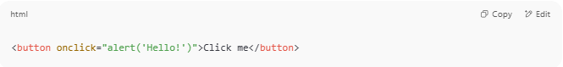
<button onclick="alert('Hello!')">Click me</button>

✅ When the user clicks the button, a popup alert appears.
That interactivity is powered by JavaScript.

🧩 What Can JavaScript Do?
# Source: AI Source: Provided by: [Data Path: Persons Table -> ID Column: 1, Name_En Column: Motasem Essam] -> From: [Chatgpt (GPT‑5 Mini)] on [1/26/2026]
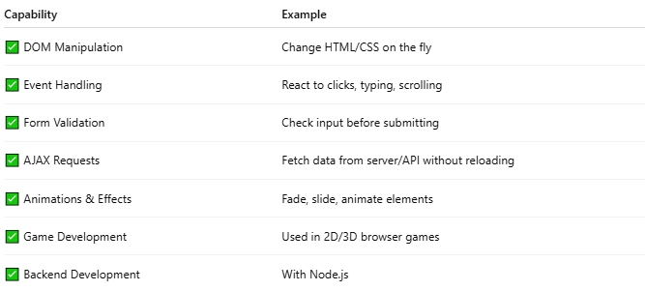
Capability | Example
✅ DOM Manipulation | Change HTML/CSS on the fly
✅ Event Handling | React to clicks, typing, scrolling
✅ Form Validation | Check input before submitting
✅ AJAX Requests | Fetch data from server/API without reloading
✅ Animations & Effects | Fade, slide, animate elements
✅ Game Development | Used in 2D/3D browser games
✅ Backend Development | With Node.js

🖥️ Where Does JavaScript Run?
# Source: AI Source: Provided by: [Data Path: Persons Table -> ID Column: 1, Name_En Column: Motasem Essam] -> From: [Chatgpt (GPT‑5 Mini)] on [1/26/2026]
- Client-side (browser) — for interactive websites
- Server-side — using environments like Node.js

🔧 JavaScript Syntax Example
# Source: AI Source: Provided by: [Data Path: Persons Table -> ID Column: 1, Name_En Column: Motasem Essam] -> From: [Chatgpt (GPT‑5 Mini)] on [1/26/2026]
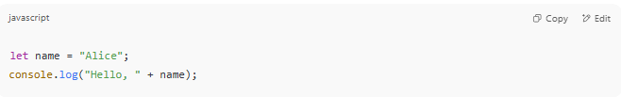
let name = "Alice";
console.log("Hello, " + name);

Output:
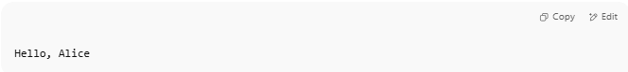
Hello, Alice

🧠 JavaScript Features
# Source: AI Source: Provided by: [Data Path: Persons Table -> ID Column: 1, Name_En Column: Motasem Essam] -> From: [Chatgpt (GPT‑5 Mini)] on [1/26/2026]
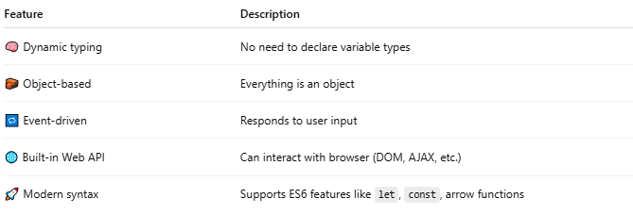
Feature | Description
🧠 Dynamic typing | No need to declare variable types
🧱 Object-based | Everything is an object
🔁 Event-driven | Responds to user input
🌐 Built-in Web API | Can interact with browser (DOM, AJAX, etc.)
🚀 Modern syntax | Supports ES6 features like let, const, arrow functions

🔄 JavaScript + HTML + CSS = 💥
# Source: AI Source: Provided by: [Data Path: Persons Table -> ID Column: 1, Name_En Column: Motasem Essam] -> From: [Chatgpt (GPT‑5 Mini)] on [1/26/2026]
JavaScript brings life to static pages:
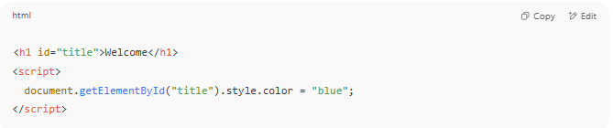
<h1 id="title">Welcome</h1>
<script>
document.getElementById("title").style.color = "blue";
</script>

✅ The heading turns blue dynamically

📌 Summary
# Source: AI Source: Provided by: [Data Path: Persons Table -> ID Column: 1, Name_En Column: Motasem Essam] -> From: [Chatgpt (GPT‑5 Mini)] on [1/26/2026]


Feature | JavaScript
Type | Programming language
Runs In | Browser (or Node.js)
Used For | Interactivity & logic
Works With | HTML & CSS
File Type | .js

